# Test plan

**Project: Movie Database**

**Client: Acme Entertainment Pty Ltd**

|  |  |  |  |
| --- | --- | --- | --- |
| **Version** | **Change Date** | **By** | **Description** |
| V0 | 28/5/2020 | *Gholamreza Aminy* | First Version |
| V1 | 7/06/2020 | *Sean Boaden* | Second Version – updated to meet requirements of Sprint Two |
| V2 | 10/06/2020 | Sean Boaden | Updated to meet requirements of Sprint Three |
| V3 | 29/06/2020 | Sean Boaden | Updated and finalised for project handover |

Test plan 1

1. Introduction 3

Scope 3

In Scope 3

Out of Scope 3

Quality Objective 3

Roles and Responsibilities 3

2. Test Methodology 4

Overview 4

Test Levels 4

Bug Triage 5

Suspension Criteria and Resumption Requirements 6

Test Completeness 6

3. Test Deliverables 6

4. Resource & Environment Needs 7

Testing Tools 7

Test Environment 7

5. Terms/Acronyms 7

## Introduction

### Scope

#### In Scope

The whole website software package, including user interface and client-side *(JS)* and server-side scripts *(PHP)*, functional and non-functional requirements of the software are in the scope of this document and will be tested in different stages and sprints.

#### Out of Scope

None

### Quality Objective

The ultimate objective of this plan is to ensure the web-application under test meets the functional and non-functional requirements as agreed on the contract assigned to *CITE Managed Services* by *ACME Entertainment Pty. Ltd*. The Application Under Test *(AUT)* will be a quality and user friendly product with no defects.

### Roles and Responsibilities

To ensure a clear understanding of the roles and responsibilities to achieve the above-mentioned quality objective the following roles and responsibilities are defined for this plan:

* **Test Manager**: has the overall responsibility of executing and updating this plan. Test manager will schedule and implement the tests and set action plans to rectify the triaged bugs in cooperation with other team members
* **QA Analyst**: QA Analyst has the responsibility to monitor the proper implementation of this plan, perform regular audits and report to the Test Manager for corrections and Project Manager for further decisions.
* **Configuration Manager**
* **Developers**: are responsible to understand and analyze the assigned tasks and do the task by a deadline ready for test. They will fix bugs during testing phases reported by the **Test Manager**.
* **Installation Team**: They are responsible to ensure the software can be installed and operated with minimum efforts and report any bugs to the Test Manager

## Test Methodology

### Overview

Choosing the RAD software development requires a suitable test method like Agile in which all the functional and non-functional tests can be completed in each sprint. So the Agile method will be used for this testing plan as in Agile:

* software is developed in incremental, rapid cycles
* Interactions amongst customers, developers and client are emphasized
* focuses on responding to change rather than extensive planning
* every release of the project is tested thoroughly
* any bugs in the system are fixed before the next release

### Test Levels

Test Levels define the Types of Testing to be executed on the Application Under Test (AUT).

The AUT will be tested in the below levels

* White Box Tests
  + **Branch Coverage tests** – can be performed on certain conditional operations. It is important that conditional bounds are tested on certain points, to ensure the application works well.
  + **Query Tests** – can be done with PHP or in a SQL test environment *(phpMyAdmin)*, depending on the type of query.

E.g. testing a query to retrieve the most rated movies in the phpMyAdmin test environment:

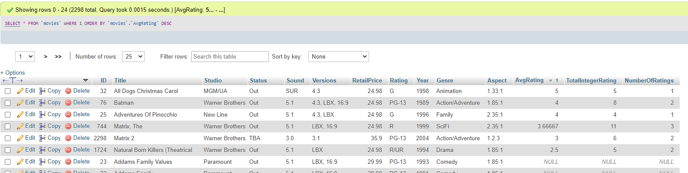

**Testing a query in PHP** is as simple as using *echo $sql;* when performing a query on a page. The query will be printed so you can see if there are any errors. Unfortunately it can be hard to control how this gets displayed.

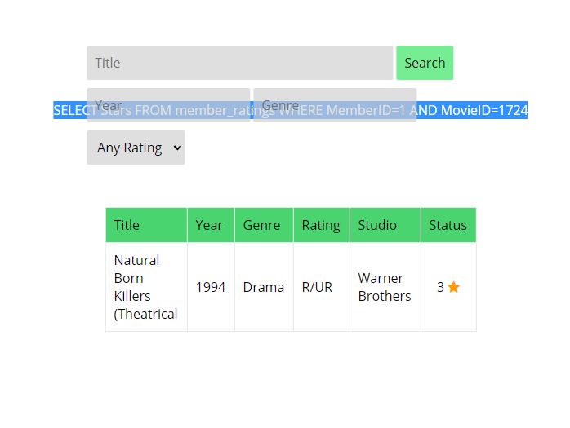

* Black Box Tests
  + **Functional tests** – where the new membership portal inputs will be tested. Sign up / sign in functions, administrative functions should be tested and documented.
  + **User interface** tests – will be used to test that the new members page follows the responsive design.

The following tests will be performed to ensure clients requirements:

* Functional and Regression Testing;
* GUI and Usability Testing;
* Accessibility Testing;
* Performance Testing;
* System / Integration Testing;
* User Acceptance Testing (UAT).

### Bug Triage

To ensure fixing the bugs in a timely manner it is absolutely important to prioritize them so that the urgent ones, which are mainly functional reuquirements, get priority in scheduling the tasks to fix the bugs.

The triage would be based on the following requirements:

* **Accessibility** – *WCAG is implemented, all non-text images have alternative text, page is readable up to 200% zoom*.
* GUI and Usability
* Functionality
* Performance

### Suspension Criteria and Resumption Requirements

Due to size of the project, there is no suspension or resumption criteria.

### Test Completeness

Test process will be considered complete if the following is met:

* 100% test coverage.
* Web Content Accessibility Guidelines
* All Manual & Automated Test cases executed
* All open bugs are fixed or will be fixed in next release

## Test Deliverables

During different phases of the testing lifecycle the following deliverables should be delivered to ensure the testing process is completed and validated:

* Test Documentation Report
  + Test Plan
  + Test Cases
  + Bug Reports
  + Test Strategy
  + Test Metrics
* Customer Sign Off

## Resource & Environment Needs

### Testing Tools

To run the testing plan the following tools are required and will be used:

* Test Management Tool
* Configuration management tool
* Static Analysis Tools [PHP Code Sniffer](https://github.com/squizlabs/PHP_CodeSniffer) with your desired coding standards

### Test Environment

To test the application a test environment including hardware and software environement is equired in addition to the client specific ones.

Required hardware:

* PC or laptop
* Modem for internet connection
* Sufficient Disk Drive space

Required software:

1. Windows 10 / Mac OS / Linux
2. Email provider / individual preference
3. Git – to clone the source repository
4. XAMPP or similar web server software packages including MySQL and Apache
5. Text Editor such as Notepad++ or Visual Studio Code

## Terms/Acronyms

Make a mention of any terms or acronyms used in the project

| TERM/ACRONYM | DEFINITION |
| --- | --- |
| API | Application Program Interface |
| AUT | Application Under Test |